How to download Fusion 360 with a free student licence.

[Follow the Link.](https://www.autodesk.com/products/fusion-360/students-teachers-educators)

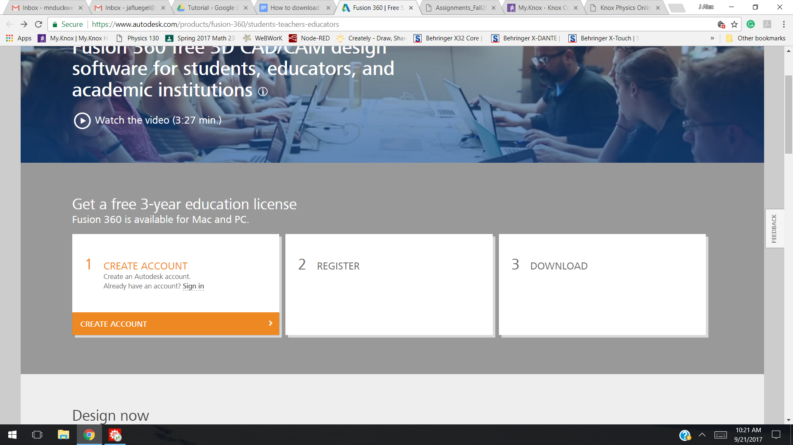

Create an account using your knox student email. Sign in and Register.

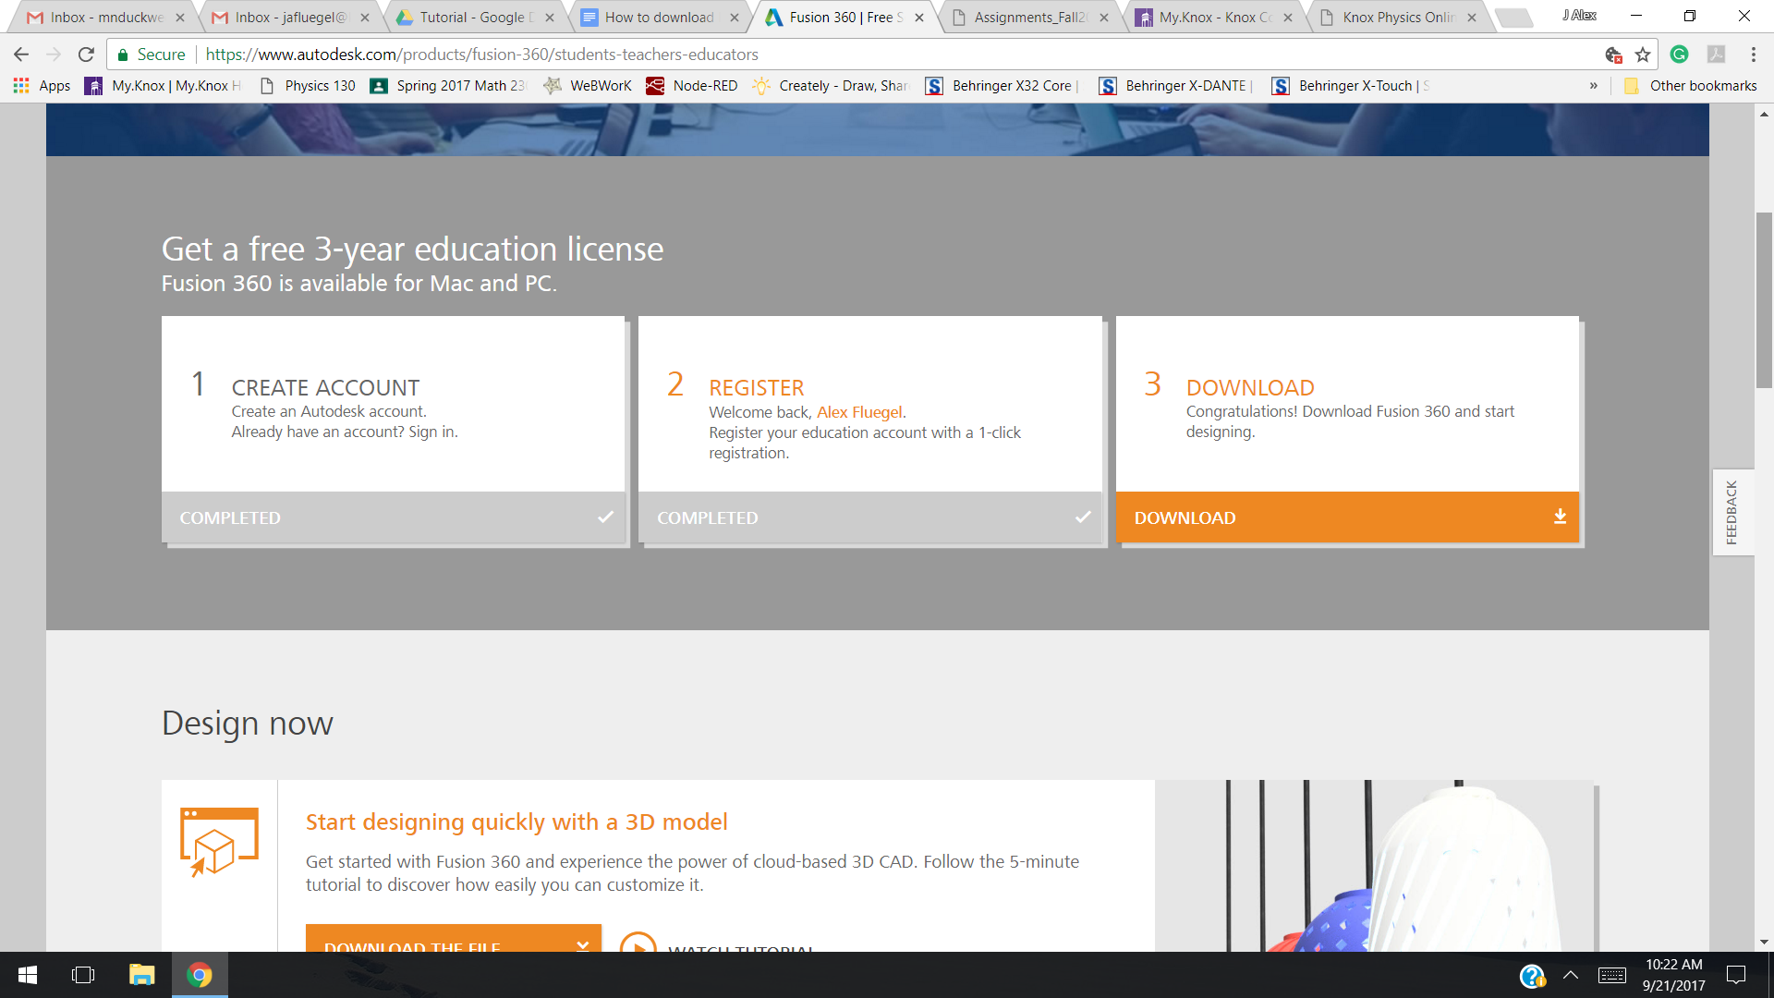

Download the installer and press run.

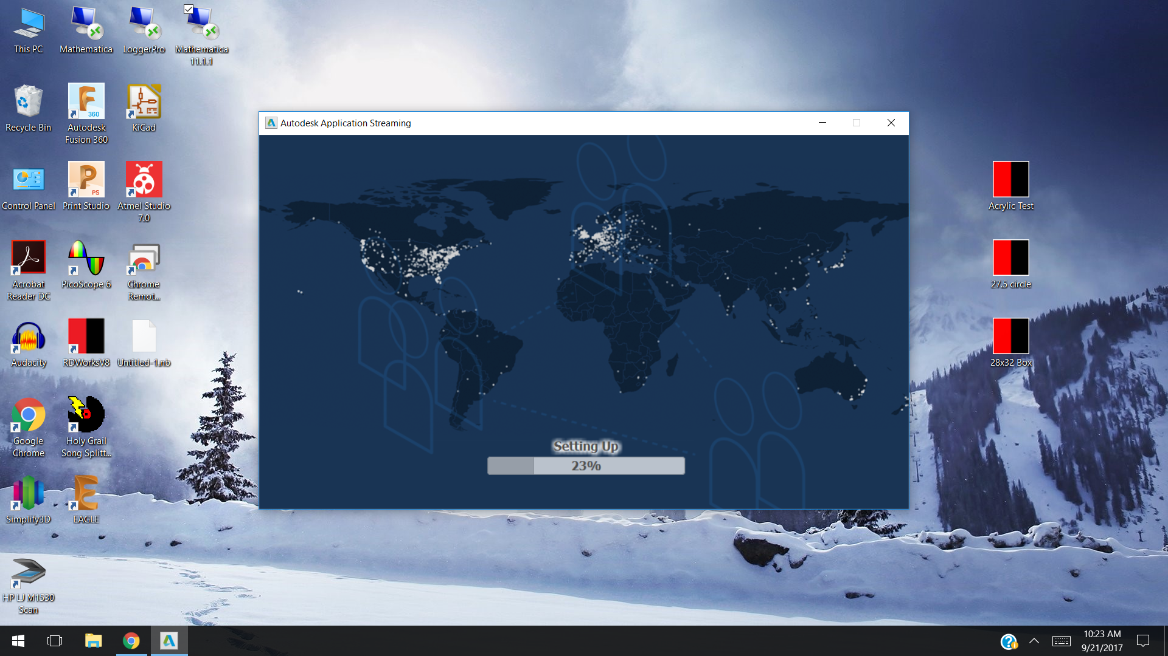

Then Sign in with your account.

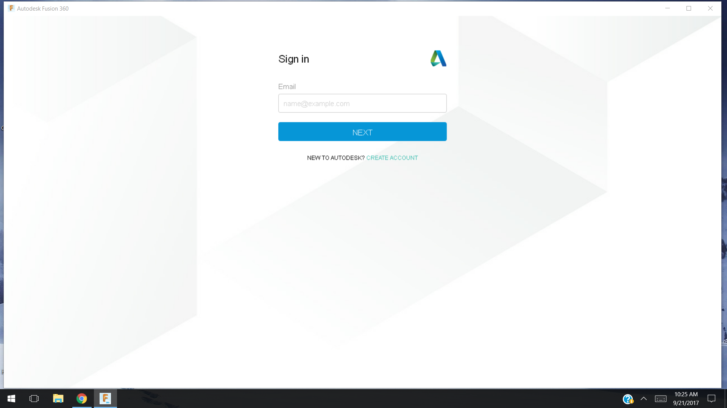

You are now successfully ready to start modeling.